Traffic Light Eating - Activity
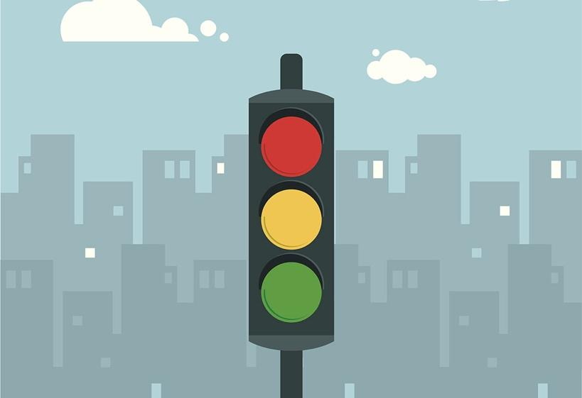

This activity is an extension of the “Traffic Light Eating” lesson in the main program.

Prepare menus for Breakfast, Lunch and Dinner using each of the traffic lights. Even though eating a small amount of red or yellow foods is okay, try to make your green menu entirely green foods for this activity. When creating the yellow and green food menus, try very hard to make sure to choose things you would like to eat!

RED LIGHT FOODS
Breakfast | Lunch | Dinner

YELLOW LIGHT FOODS
Breakfast | Lunch | Dinner

GREEN LIGHT FOODS
Breakfast | Lunch | Dinner

Follow up discussion:
- What thoughts or experiences did you have when doing this activity?
- Reflect on how you feel after eating a mostly red light meal, yellow light meal, and green light meal.
- What are some ways to incorporate more green light foods in one’s diet?
- (Note: remember to eat mostly healthy foods, and eat less healthy foods in moderation…it’s ok to have a treat sometimes because it’s what you put in your body on a regular basis that matters most!)

EXAMPLE MENUS:

RED LIGHT FOODS
BREAKFAST | LUNCH | DINNER
12 oz. vanilla latte | 2 pieces of fried chicken | McDonald’s Big Mac
2 glazed donuts | 16oz Mountain Dew | Large fries
 |  | 16 oz. diet coke
 |  | Slice of apple pie

YELLOW LIGHT FOODS
BREAKFAST | LUNCH | DINNER
1 bowl Corn Flakes | Ham and American cheese sandwich on white bread | 3 ground beef tacos with tomato, cheese and lettuce
½ cup whole milk | Baked potato chips | ½ cup refried beans
White toast with butter and strawberry jam | 1 bag fruit snacks | ½ cup white rice
8 oz. orange juice | Sweet tea | 16 oz. Gatorade

GREEN LIGHT FOODS
BREAKFAST | LUNCH | DINNER
1-2 scrambled eggs | Whole wheat bread with natural peanut butter and fruit spread. | Baked chicken with brown rice
1 cup cold cereal made with whole grains and no sugar | 1 orange | Steamed broccoli
8 oz. 1% or 2% milk | Carrot sticks and cucumber slices | Sliced strawberries and blueberries
1 banana | 16 oz. water | 16 oz. water

