School Lunch Survey - Activity

Students pair up and survey another student about their lunch habits at school. They record their responses on the whiteboard or a place where all students’ responses can be written down, compiling the data into one place. Students can even create visual data representing the responses, such as graphs or pie charts (see examples below) to view the class's habits at a glance. Afterward, students discuss the results.

Have a class conversation about school lunch. Some suggested questions:

- What do you see in this data about our class's experience with school lunch? (Literally, what does the data say. Eg. I notice that about half the class eats in the cafeteria every day.)
- Do students seem generally happy with the school lunch that is provided or not?
- What changes do you think could make our school lunches healthier?
- What kind of things can be done–not related to food–that would balance out less healthy choices? (refer to the Energy Balance Beam in Case Study #1).

School Lunch Survey

Please give your best answer by marking your choice.

1. How often do you eat in the cafeteria?
- Never
- Sometimes
- Depends on the menu items
- Everyday

2. If you marked “Never” above, what is the reason you don’t eat in the cafeteria?
- Cost of food
- Don’t like food offered
- Cafeteria too crowded
- Other:_______________________________________________________

- Please go to question 6 if you never eat in the cafeteria.

3. On a scale of 1-10 rate the food offered in the cafeteria. (1 being the lowest rating, 10 is the highest)
Flavor
Smell
Freshness
Temperature of food
Variety

4. What is your favorite food offered in the cafeteria?

5. What is your least favorite food offered in the cafeteria?

6. In your opinion, how healthy is the food offered in the cafeteria? Circle one.
- Healthy
- Somewhat Healthy
- Somewhat Unhealthy
- Unhealthy
7. If the cafeteria offered healthier choices, would you be more likely to try them?
- Yes
- Occasionally
- Maybe
- No

8. In your own words, what do you think the cafeteria could do to improve the food?___________________________________________________________

________________________________________________________________

________________________________________________________________

Examples of visual data using students’ answers to the survey
Question #1: Average frequency of students eating in the cafeteria
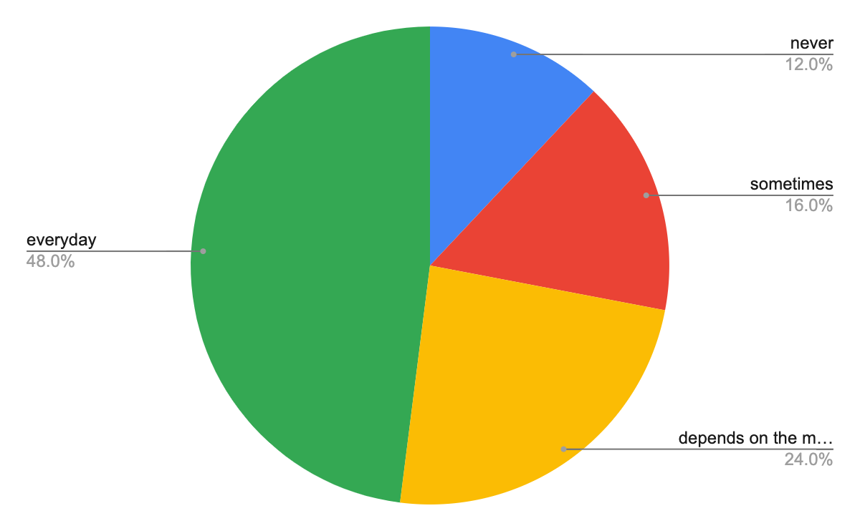
Question #3: Average student ratings of the food offered in the cafeteria
