**Let’s Get Physical - Lesson Plan**

**Goal**

* To encourage students to include daily physical activity or exercise into their healthy lifestyle.

**Objectives**

By the completion of this lesson plan, students will be able to:

* Explain the importance of daily physical activity or exercise
* State the recommended amount of time adolescents ages 6-18 should spend doing physical activity or exercise for good health
* Explain how carbohydrates, proteins and fat fuel the body for physical activity or exercise
* Understand the importance of water during physical activity or exercise

**Related Activities**

Physical Activity Challenges: Find Someone Who

Let’s Get Physical: Something to Try at Home

**Lesson Plan**

1. **Exercise and Physical Activity**

* Calisthenics are a form of exercise that only relies on a person’s own body weight. These exercises are done on different levels and rhythms.
* Over time and regular practice, calisthenics will develop strength, endurance, flexibility and coordination of the body.
* Examples of calisthenics:

Jumping jacks

Push-ups

Chin-ups

Sit-ups

Lunges

* Physical Activity is a way to move the body without doing a specific exercise.

Examples of physical activity:

Walking

Running

Stair climbing

Raking leaves

Shoveling snow

Gardening

Dancing

* Benefits to the body when physically active or exercised include:

The condition of the heart grows stronger

Excess calories are burned off

Oxygen is moved to the body’s cells

Bones are strengthened

Muscles are strengthened

Elevates mood

Increases flexibility

* Overtime, physical activity and exercise build up endurance and stamina.
* The CDC (Center of Disease Control and Prevention) recommends 60 minutes of physical activity each day for adolescents aged 6-18 years. This activity should include moderate-vigorous exercise. The 60 minutes can be broken down to segments of 15, 20 or 30 minutes with the same benefits.

**2. How carbohydrates, fats, and protein fuel the body**

* Carbohydrates (usually from grains, vegetables, fruits, and sugar) provide your body with energy. Carbohydrates are broken down into glucose. The pancreas creates insulin which allows the cells to use the glucose. The body is very efficient at getting fuel from carbohydrates. Good sources of carbohydrates are in the grains, and fruit and vegetable groups. Sugars are an unhealthy source of carbohydrates.
* Fats are broken down in the intestine into fatty acids and glycerol. They are stored as adipose tissue or “fat” in the body.
* Fat stores are not utilized for energy right away. The body looks for carbohydrates first.
* When the body has used up all the available carbohydrate energy, it starts to burn stored fat for energy.
* It takes a few minutes for the process of using fat as energy to occur. If you want to burn fat in the body, exercising for at least 20 minutes is a good way to do that.
* Healthy fat comes from a variety of healthy foods:

Avocados Cheese

Dark Chocolate Whole Eggs

Fatty fish Nuts

Chia Seeds Extra-Virgin Olive Oil

Coconut Coconut Oil

Full-fat yogurt (low fat yogurt without added sugars is healthier)

* If the body doesn’t get enough of carbohydrates and fat for its fuel, it will use amino acids from protein.
* The body needs proteins for several reasons. Proteins help build lean muscle tissue whether it is repairing or replenishing muscle fibers. Muscle fibers tear as the body exercises.
* The body needs protein for enzyme and hormone development.
* The body also needs protein for hair and bone growth and healing wounds.
* Even though protein is not the preferred source of energy, the body will rely on amino acids from protein when there aren’t enough carbohydrates and fatty acids to draw on for energy.
* The most common protein sources are animal-based. This includes beef, poultry, pork, fish, eggs, and dairy products such as milk and yogurt. Animal protein sources tend to have more fat than plant-based proteins.
* Plant-based proteins include beans, grains, nuts and seeds.

**3. The importance of staying hydrated**

* The body is about 66% water.
* Water is lost when the body sheds it when breathing, sweating and urinating.
* When the body is physically active or exercised it loses even greater amounts.
* Drinking eight cups of water each day is recommended. 1 cup = 8 ounces.
* Water regulates the body temperature.
* Water moistens tissues in the nose, mouth and eyes.
* Water protects the body’s organs and tissues.
* Water carries nutrients and oxygen to the cells.
* Water keeps joints lubricated.
* Water flushes out waste products from the liver and kidneys.
* Minerals and nutrients are made accessible to the body because water dissolves them.

**The Wrap Up**

* To be healthy the body needs to have regular physical activity and exercise.
* There are many different types of exercises that benefit the body.
* Physical activity does not have to be a certain type of movement. It can include everyday chores, walking, using the stairs, dancing and more.
* Carbohydrates, fat, and protein provide fuel for the body.
* There are a variety of healthy foods that can provide energy.
* Water is most important for the body to maintain health.

**PHYSICAL ACTIVITY CHALLENGES**

The following exercise will not only get students up and moving, it will help them understand how important physical activity is each day.

Using the following sheet with “activity cards”, students will find others in their group or class who fits the card’s criteria and then complete the challenge on the card. Students can mark off cards after completing the challenges.

Alter as works best for your group.

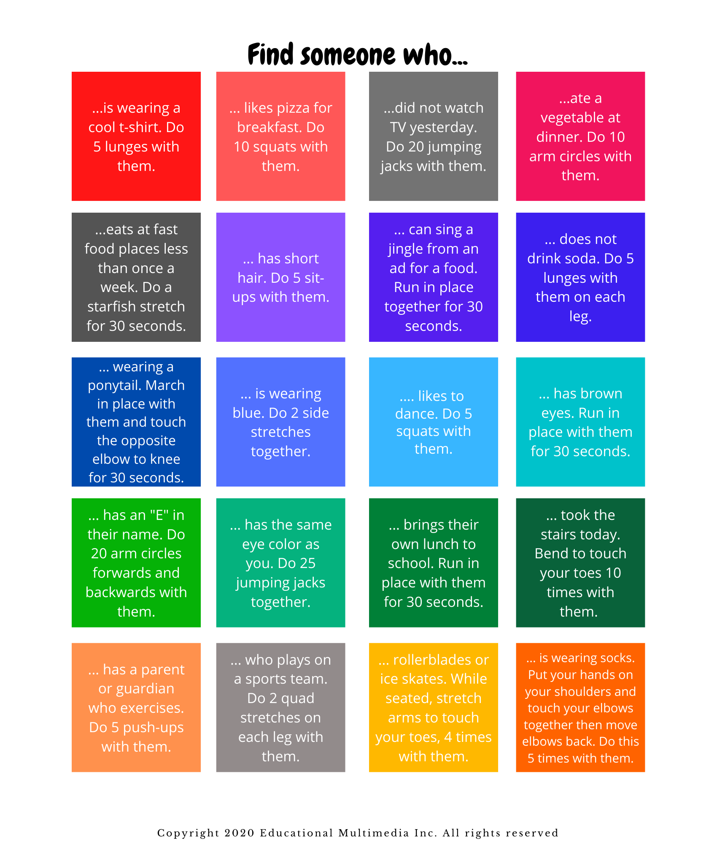

"**Let’s Get Physical": Something to Try at Home**

**Challenge:** For **one day** drink 8 cups of water!

**Guidelines**:

1 cup of water is 8 ounces. (If you drink a 16 ounce bottle of water, you’ve had 2 cups.)

Water means water; you must drink plain water with nothing else in it.

Try to get your water in before you choose things like soda, fruit punch or other drinks (except milk).

Use the table below to mark off each cup of water as you drink it.

| **Cup of Water #1** | **Cup of Water #2** | **Cup of Water #3** | **Cup of Water #4** |
| --- | --- | --- | --- |
|  |  |  |  |
| **Cup of Water #5** | **Cup of Water #6** | **Cup of Water #7** | **Cup of Water #8** |
|  |  |  |  |

Write down any thoughts or comments you had on this activity below:

______________________________________________________________________________________________________________________________________________________________________________________________________________________________________________________________________________________________________________________