**Food Label Fun - Lesson Plan**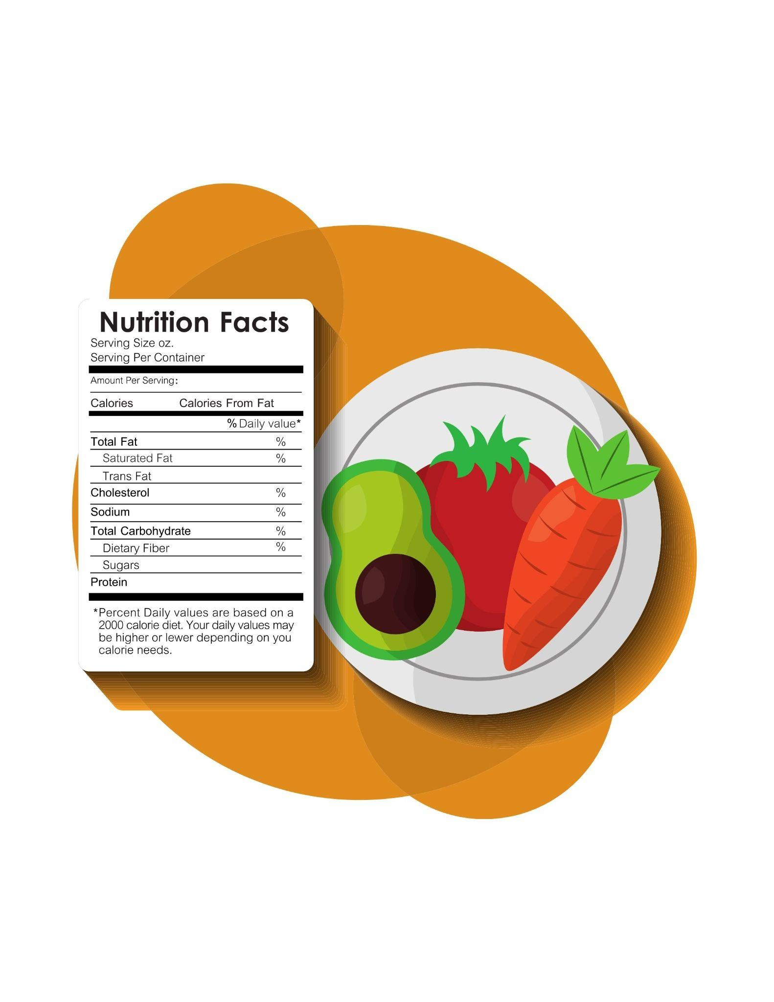

**Goal**

* To use food labels to make better choices.

**Objectives**

* After this lesson, student will be able to:
  + find the number of servings on a food label
  + compare food labels on similar items

**Related Handouts/Activities (found below)**

* The Nutrition Facts
* What’s in That Food?
* The Great Cereal Caper

**Lesson Plan**

1. **Food labels show consumers what nutrients are in a food.**
   * Optional: Have students collect food labels from foods they eat and bring to class.
   * A food label can guide our food choices by allowing us to pick foods that fit into our diet.
     + If we are looking for low fat, high fiber foods, the food label can show us that.
     + If we are looking for a high protein food to complement our meal, the food label will show us that also.
   * The food labels are a standardized way to tell us what is in the food.
   * It also helps to regulate what a producer can claim about their food.
   * Food labels can show us if we should avoid a food because of a food allergy or a certain medication that reacts with that food.
2. **Let’s look at a food label.** 
   * Let’s look at the ingredient list on our food label.
     + The ingredients that are listed first are in the greatest quantity in the product, while those listed last are in the least quantity.
     + Generally, we want to limit the foods with lots of fats and sugars.
     + The ingredient list can also warn you if there are things in this food you might be allergic to like peanuts, soy, monosodium glutamate (MSG) or aspartame (Nutrasweet).
     + It can also tell you how natural the food is. If a food has lots of chemicals or words you cannot pronounce, it may be something you want to eat less often.
3. **All food labels are required to include calories, total fat, sodium, total carbohydrate, sugars and protein. See “The Nutrition Facts” handout below)**
   * Other information may be included if it is pertinent to the food.
   * You may notice other nutrients on the food label besides those mentioned above. (For example, monounsaturated fats, dietary fiber, and cholesterol.)
   * You may also see vitamins and minerals on the food label. (For example, vitamin A, vitamin C, iron or calcium.)
   * This information can help you make better food choices.
   * Becoming familiar with food labels takes time and practice. Once you begin reading food labels, you will be able to compare food items quickly.
4. **The food label shows us how many servings are in a food package.** 
   * Look at #1 on the sample label below.
   * Serving sizes make it easier to compare similar foods.
   * Some food packages have multiple servings such as extra large sodas or bags of chips.
   * The food label shows the nutrients in **one** serving. If you eat two servings then you are eating twice as much of each nutrient listed on the food label.
   * Many times, we eat more than one serving of a food without knowing it. Eating extra servings of fruits and vegetables isn’t a problem. Eating multiple servings of high fat or high sugar snacks may provide more energy than our body can use.
   * Eating only one serving size of a product is an easy way to instill moderation into our diet.
   * Caution! It’s important to read the label carefully when it comes to serving size.
5. **Calories provide a measure of how much energy you get from a serving of food.**
   * Look at #2 on the sample label.
   * A calorie is a measurement of energy. You consume calories when you eat food. You burn calories when you exercise. Many Americans get more calories than they need without getting all the nutrients they need.
   * If your portion amount is more than one serving of a food, you are eating more calories than what is listed on the food label. Look at #2 on the sample label.
     + - There are 280 calories in one serving of this lasagna. What if you ate the whole package content? Then, you would consume four servings, or 1120 calories.
     + Eating extra energy (measured as calories) each day may lead to overweight or obesity, which increases the risk of certain diseases.
6. **Limit these nutrients: Fats, cholesterol and sodium need to be limited each day to reduce the risk of certain diseases.**
   * Look at #3 on the sample label.
   * “Limit these Nutrients” refers to saturated fat, trans fat, cholesterol, and sodium.
   * Eating too much of these nutrients can increase the risk of developing heart disease or high blood pressure.
7. **Get enough of these nutrients: Strive to get more dietary fiber, vitamin A, vitamin C, calcium, and iron in your diet**.

* Continue to look at #3 on the sample label
* “Get Enough of these Nutrients” refers to dietary fiber, vitamin A, vitamin C, calcium, and iron
* Eating a diet high in dietary fiber helps sweep toxins out of your body.
* A healthy diet would include many vegetables, fruits, and whole grains while being low in saturated fat and cholesterol.
* Eating enough of these nutrients each day is part of a healthy diet and may reduce your risk of some diseases.
* The food label helps us to increase the nutrients we want more of while decreasing the nutrients we need less of.

1. **The Percent Daily Value (%DV) written on the right side of the label explains how much of the nutrient this food provides based on a 2,000 calorie diet.**
   * Look at #4 on the sample label.
   * The %DV helps you determine if a serving of food is high or low in a nutrient.
   * Some nutrients, liketrans fat, do not have a %DV because they are very unhealthy and should be avoided.
   * You don’t need to do math to use the %DV.
   * Each nutrient is based on 100% of the daily requirements for that nutrient (for a 2,000 calorie diet).
     + How do you know if a food is high or low in a particular nutrient?
       - **5%DV or less is low.** For those nutrients you want to limit (for example, fat, saturated fat, cholesterol, and sodium), look for food that have 5%DV or less of these nutrients. But for those that you want to consume in greater amounts (for example, fiber and calcium) this is considered too low.
       - **20%DV or more is high.** For those nutrients you want to limit (for example, fat, saturated fat, cholesterol, and sodium), this is too high and indicates a food to avoid. But for those nutrients that you want to consume more of (for example, fiber and calcium), look for 20%DV or more.
       - Look at your food label. The Daily Value for sodium is 20%. If you were trying to limit sodium, is this a good choice or not? (No, because 20% is high.)
       - Look at your food label again. The Daily Value for fiber is 0%. If you were trying to increase your fiber, is this a good choice or not? (No, because 0% is low.)

**Optional Activity: What’s in That Food**

1. **Once you feel comfortable reading food labels, you can use that knowledge to create healthy meals and snacks for you and your family.**
   * At the grocery store, compare food labels when you are picking between two items. For example:
     + In the meat section, compare grams of fat and saturated fat.
     + In the bread aisle, compare grams of fiber per slice.
   * Some key points in meal planning include mixing high fat options with low fat options.
   * Include a protein (meat, beans or dairy), a grain, a fruit and a vegetable to create a balanced meal.
   * Remember to watch serving sizes when you are preparing and serving your meals and snacks. Strive for moderation!
2. **Wrap-up**
   * The food label shows us how many servings are in a packaged food.
   * Calories provide a measure of how much energy you get from a serving of food.
   * All food labels are required to include calories, total fat, sodium, total carbohydrates, sugar and protein.
   * Food labels show consumers what nutrients are in a food.
   * Saturated and trans fats, cholesterol, and sodium need to be limited each day to prevent certain diseases.
   * Most Americans don’t get enough dietary fiber, vitamin A, vitamin C, calcium or iron in their diets.
   * The Percent Daily Value (%DV) written on the right side of the label explains how much of the nutrient this food provides based on a 2,000 calorie diet.
   * Once you feel comfortable reading food labels, you can use that knowledge to create healthy meals and snacks for you and your family.

**Handout:** The Nutrition Facts

Text Box 9

**Activity:** What’s in that Food?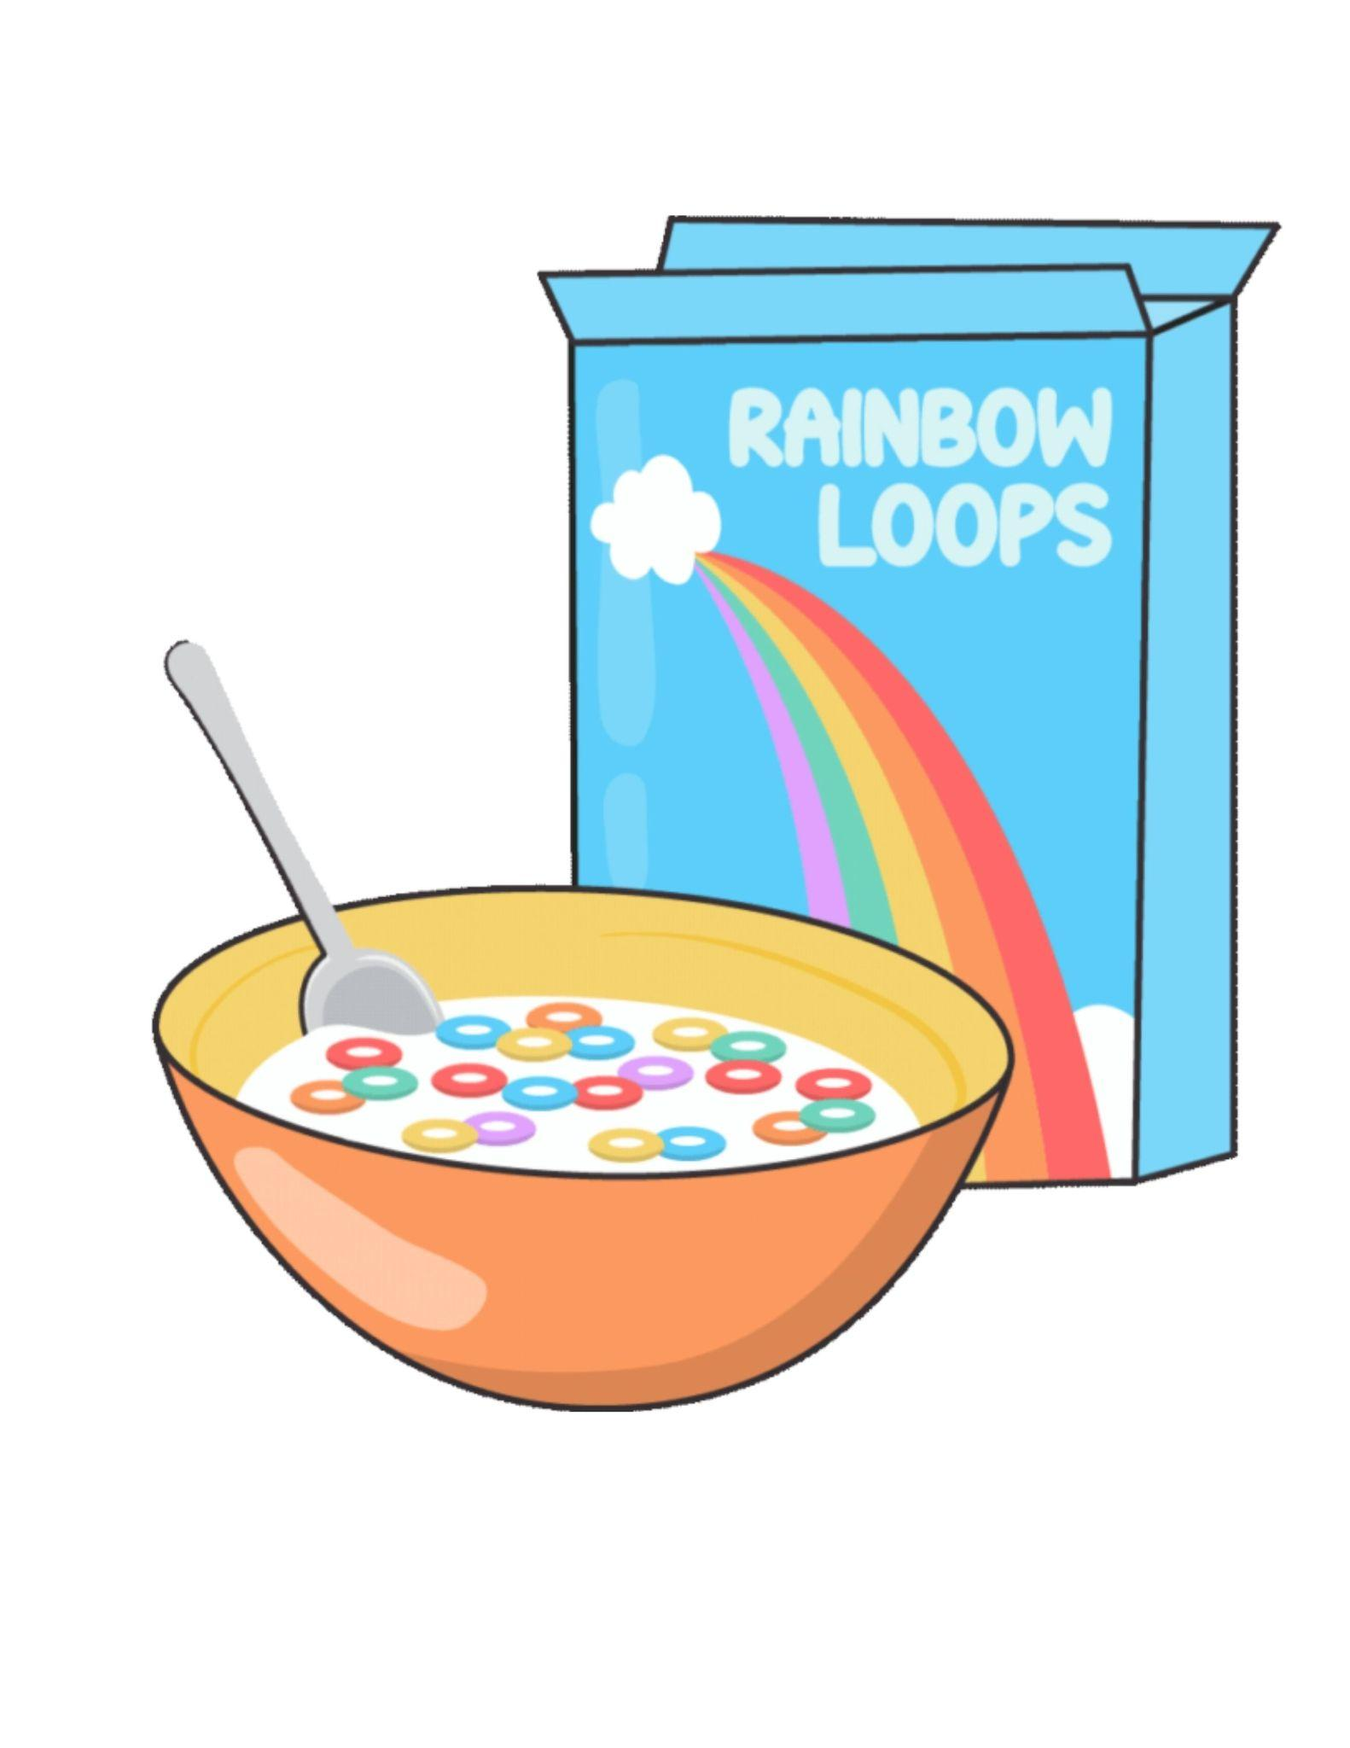

Instructions: Select a food from home and locate the food label.

(If printing out this worksheet: Cut the food label off of the package and attach it to this paper.)

Answer the questions below based on your food label.

1. How many servings does this package provide? ____________
2. How many calories are in each serving? ____________
3. How much saturated fat does it have? ____________
4. Does it have any trans fat in it? ____________
5. How many carbohydrates are in it? ____________
6. How many grams of sugar does it have? ____________
7. How much protein is in it? ____________
8. Does it give you any vitamins or minerals? ____________
9. Which do you think this is?

______A food to eat often ________A food to limit

Below, record any other thoughts or comments you have after doing this activity.

_________________________________________________________________________________

_________________________________________________________________________________

_________________________________________________________________________________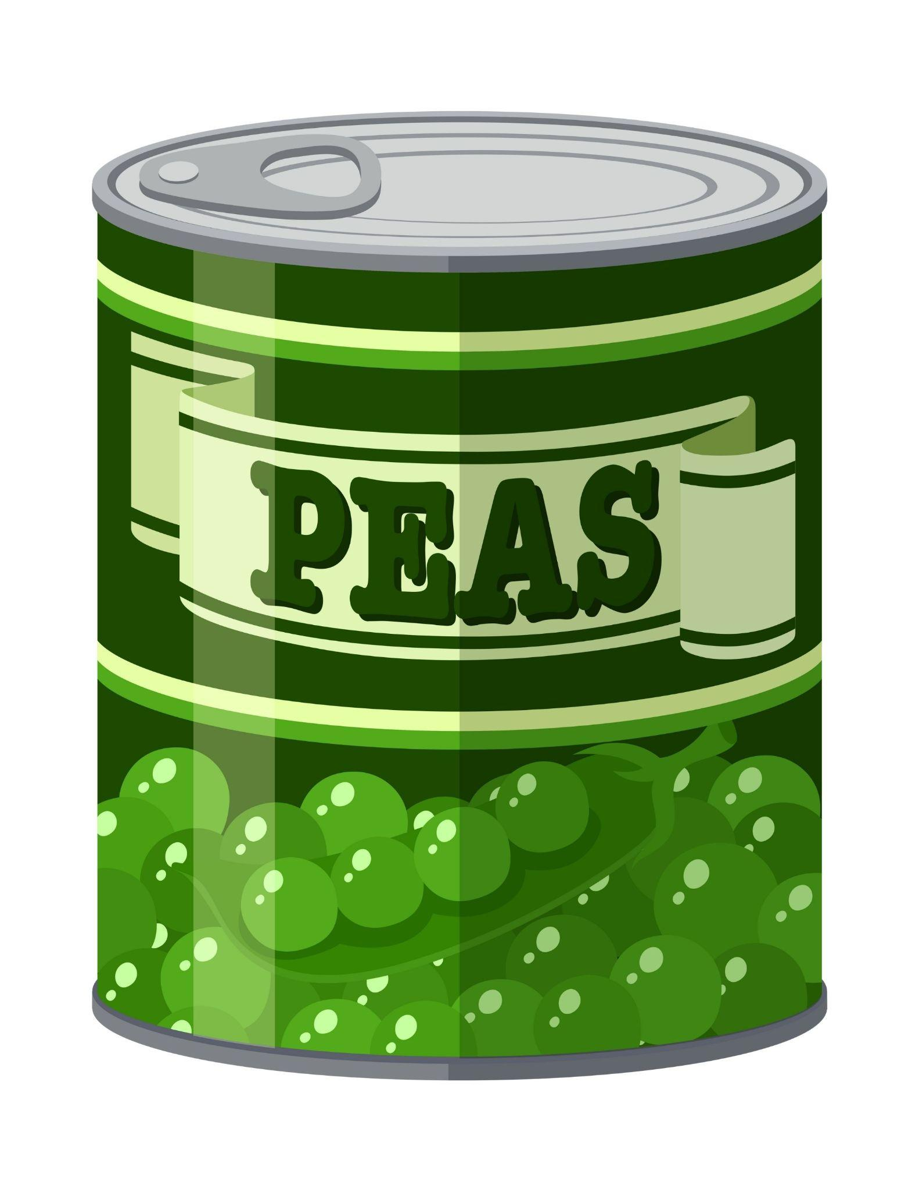

**The Great Cereal Caper**

**Part 1**

**Instructions:**

* Have a box of your favorite cereal
* Using the information on the food label answer the questions below
* Respond to the questions with a 0 or 5.

1. **Checking for Whole Grains:**

Is the first ingredient listed on the package a whole grain? If so, give yourself 5 points. If not, give yourself 0 points. __________

1. **Checking for Fat:**

Does your cereal contain less than 2 grams of fat per serving? If so, give yourself 5 points. If not, give yourself 0 points. __________

Does your cereal contain any trans fat per serving? If so, give yourself 0 points. If not, give yourself 5 points. __________

Does your cereal have any “hydrogenated oil” or “partially hydrogenated oil” in the ingredients? If so, give yourself 0 points. If not, give yourself 5 points. __________

1. **Checking for Sugar:**

How many grams of sugar are listed on the Food Label? If there are less than 10 grams per serving, give yourself 5 points. If there are more than 10 grams per serving, give yourself 0 points. __________

1. **Checking for Fiber:**

How many grams of fiber are listed on the Food Label? If there are more than 5 grams, give yourself 10 points. If there are 3-5 grams, give yourself 5 points. If there are less than 3 grams per serving, give yourself 0 points. __________

1. **Checking for Vitamins and Minerals:**

Does your cereal contain at least 25% of one of the vitamins and minerals listed on the label? If so, give yourself 5 points. If not, give yourself 0 points. __________

**Total Points:** __________

How many points did your cereal score?

**30-40 total points:** This cereal has lots of nutrients! It is a good everyday choice.

**20-25 total points:** This cereal provides some nutrients but not as many as other cereals. Eat it only a few times a week.

**0-15 total points:** This cereal has fewer healthier nutrients than other cereals and may be higher in less healthy nutrients. Limit how often you eat this cereal to one time a week.

**Part 2**

**Instructions:**

Now, exchange cereal boxes with someone else in your classroom and repeat this activity.

* Using the information on the food label, answer the questions below
* Respond to the questions with a 0 or 5.

1. **Checking for Whole Grains:**

Is the first ingredient listed on the package a whole grain? If so, give yourself 5 points. If not, give yourself 0 points. __________

1. **Checking for Fat:**

Does your cereal contain less than 2 grams of fat per serving? If so, give yourself 5 points. If not, give yourself 0 points. __________

Does your cereal contain any trans fat per serving? If so, give yourself 0 points. If not, give yourself 5 points. __________

Does your cereal have any “hydrogenated oil” or “partially hydrogenated oil” in the ingredients? If so, give yourself 0 points. If not, give yourself 5 points. __________

1. **Checking for Sugar:**

How many grams of sugar are listed on the Food Label? If there are less than 10 grams per serving, give yourself 5 points. If there are more than 10 grams per serving, give yourself 0 points. __________

1. **Checking for Fiber:**

How many grams of fiber are listed on the Food Label? If there are more than 5 grams, give yourself 10 points. If there are 3-5 grams, give yourself 5 points. If there are less than 3 grams per serving, give yourself 0 points. __________

1. **Checking for Vitamins and Minerals:**

Does your cereal contain at least 25% of one of the vitamins and minerals listed on the label? If so, give yourself 5 points. If not, give yourself 0 points. __________

**Total Points:** __________

How many points did your cereal score?

**30-40 total points:** This cereal has lots of nutrients! It is a good everyday choice.

**20-25 total points:** This cereal provides some nutrients but not as many as other cereals. Eat it only a few times a week.

**0-15 total points:** This cereal has fewer healthier nutrients than other cereals and may be higher in less healthy nutrients. Limit how often you eat this cereal to one time a week.