**Fat and Your Diet - Lesson**

**How to include fat in a healthy way**

**Goal:**

To know three different kinds of fats and how each affects your body.

To know the benefits and risks of storing fat (adipose tissue) in your body.

To know how to safely increase or reduce stored body fat.

To know which foods contain healthy fats and which contain unhealthy fats.

To know how to make healthier food choices.

**Objectives:**

Students will be able to:

· List the benefits of eating unsaturated fat.

· List possible risks of eating saturated fat and trans fat.

· List the benefits of having adipose tissue in your body.

· List health risks of having too much adipose tissue or fat on your body

· Demonstrate knowledge of how to increase and reduce stored fat.

· Be able to identify foods that are good sources of healthy fats.

· Identify foods to avoid because they contain saturated or trans fat.

· Convert an unhealthy recipe into a healthier one.

· Adjust food consumption for lower fat and healthier fat intake.

**Materials Needed:**

· High fat recipes

· Food labels for recipe ingredients

· Paper and pencil or word processor for rewriting recipes

**The Big Picture:** There are three **macronutrients**: protein, carbohydrates, and fat. Each is important to the body. Each comes in forms that are healthier and less healthy. Each should be eaten in moderation.

**What are the different types of fat?**

**Unsaturated Fat**: Unsaturated fat is always liquid at room temperature. It can be found in plant and animal sources. Unsaturated fats include olive oil, soybean oil, corn oil, nuts, fish, and avocados. **Omega-3 fatty acids** are a form of unsaturated fat and are essential to the diet.

Unsaturated fat is considered heart healthy because it lowers LDL cholesterol. LDL is sometimes called the BAD cholesterol because it causes plaque in your arteries, heart attacks, and strokes.

**Saturated Fat**: Saturated fat is always solid at room temperature. It is mostly found in animal products such as beef, bacon, chicken, eggs, cream, and butter. Some plants also contain saturated fat, such as coconut and palm kernel oil. Coconut and palm kernel oil are found in purchased baked goods like cookies, crackers, and many snack foods.

Saturated fat is not a heart healthy food item and would best be eaten in small quantities. Too much saturated fat will raise LDL cholesterol. Remember, LDL is the BAD cholesterol because it causes plaque in your arteries, heart attacks, and strokes.

**Trans Fat**: Like saturated fat, trans fat is solid at room temperature. The difference is trans fat is created by forcing liquid fat into solid fat. It can be found in commercial baked goods like cookies, crackers, and frozen pizza crust. It is in most margarine, microwave popcorn, and nonfat dairy creamer. It can also be found in most fried foods such as french fries, onion rings, and fried chicken. Trans fat is not a recommended part of the diet.

Trans fat is especially bad for heart health because it raises LDL (the bad cholesterol) and lowers HDL cholesterol (the good cholesterol).

**Why is fat important in our diet?**

Fat is necessary for the absorption of fat-soluble vitamins A, D, E, and K. If you eat a carrot, the vitamin A in the carrot cannot be absorbed in the body unless there is fat present. Fortunately, there is a small amount of fat in a carrot, so you don’t need to eat extra fat to get your vitamin A!

One type of unsaturated fat, Omega**-3 fatty acid**, is an **essential nutrient**. An essential nutrient is a nutrient that can only be obtained from food because our body cannot make it. Omega-3 fatty acids have anti-inflammatory properties.

**Inflammation** causes the body to become red, swollen, hot, and painful. It occurs after an injury but can also occur inside the body for unknown reasons. Omega-3 fatty acids can prevent inflammation in the body, reducing the risk of some diseases such as cancer, cardiovascular disease, asthma, and arthritis.

Unsaturated fat, and especially Omega-3 fatty acids, are healthy when consumed in moderation. Saturated fats and trans fats are unhealthy and should be avoided.

**What is fat stored in the body called and what does it do?**

Fat stored in the body is called **adipose tissue**. When food is consumed in excess, it is stored for later use as adipose. Women naturally store more adipose tissue than men. Adipose tissue is healthy in moderate amounts. As a storage form, fat protects our internal organs and acts as heat insulation. When an adequate food supply is not available, fat stores in the body can be used for energy.

Excess adipose tissue is a sign of a food intake/exercise imbalance. When excess body fat reaches a certain level, a person is considered to have **obesity**. This condition puts one at risk for **heart disease**, diabetes, and cancer.

**What is the energy balance beam?**

A **calorie** is a unit of energy. You take in energy, or calories, when you eat and drink. You burn energy, or calories, as you undergo your daily activities. You even burn calories when you sleep. The more you move and exercise, the more calories you burn.

A person’s **activity level** indicates how many calories one must consume to maintain current weight. A person’s food intake indicates how much exercise one must get to maintain current weight.

The energy balance beam shows the relationship of food consumption and exercise. If you eat more calories than you burn in activity, you will likely gain weight. If you eat fewer calories than you burn in your daily activities, then you will likely lose weight. You can change the balance by changing either caloric intake or by changing calories burned.

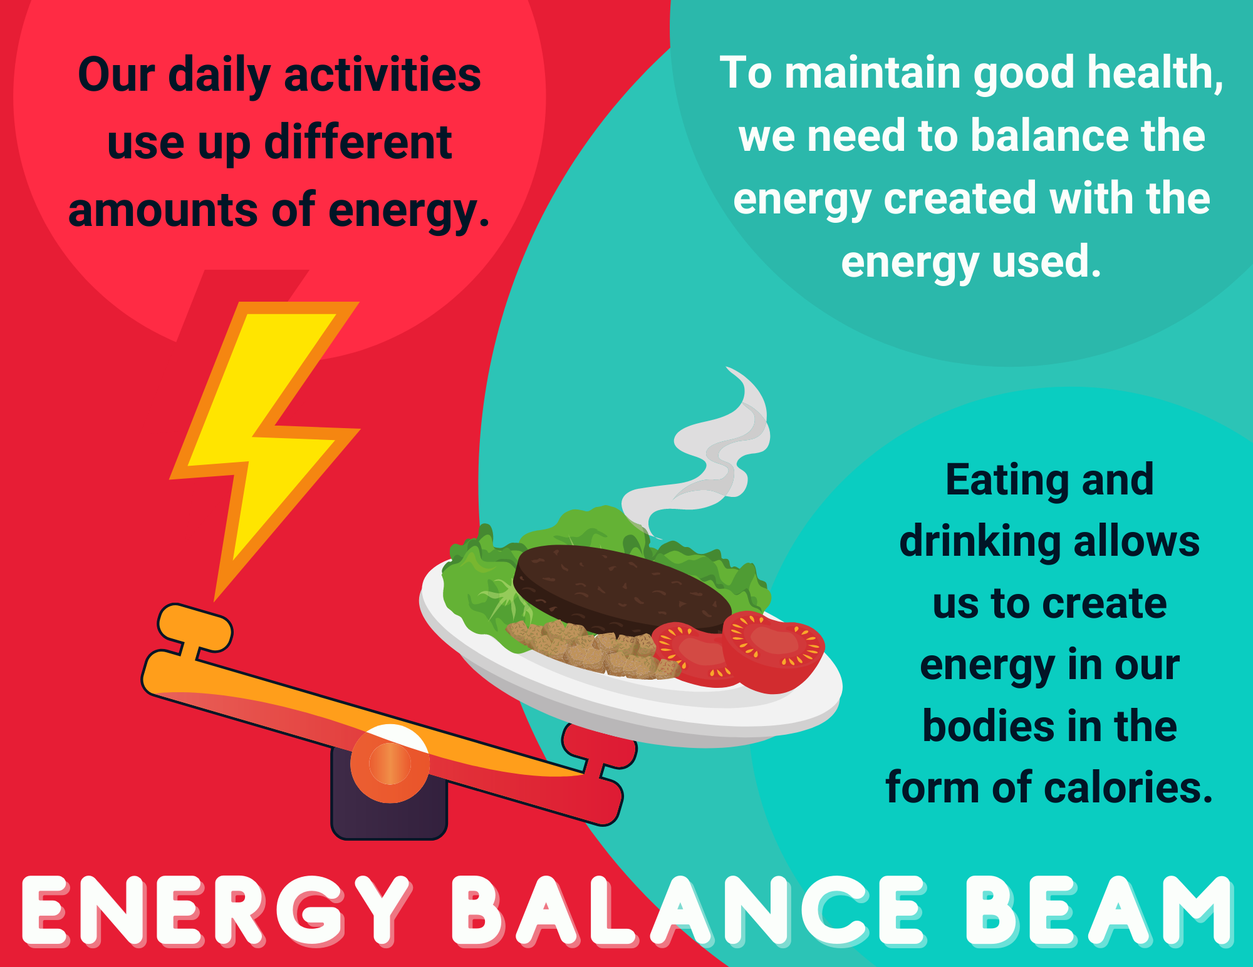

A change in weight does not occur quickly. If you want to change your weight, the best plan is to make small, healthy, and consistent changes in what you eat and how much you exercise.

If you are trying to lose weight, you could increase your activity and/or decrease unhealthy calories such as saturated and trans fats and refined carbohydrates. If you are trying to gain weight, increasing healthy fats, proteins and complex carbohydrates will help. Exercising increases muscle mass which also increases healthy weight.

Here are the recommended calorie requirements for youth:

| **For ages 9-18** | | |
| --- | --- | --- |
| **Sedentary** | **Moderately Active** | **Active** |
| Girls: 1,600-1,800 calories/day | Girls: 2,000-2,200 calories/day | Girls: 2,200-2,400 calories/day |
| Boys: 2,000-2,400 calories/day | Boys: 2,200-2,800 | Boys: 2,600-3,000 calories/day |

A person is in the “active” category if they do vigorous activities for about 2.5 hours per week. Examples of vigorous activities would be running, swimming laps, or playing soccer. A “moderately active” person does less intense activities for 2.5 hours a week or more, such as walking, riding a bike, gardening or dancing. Those who are “sedentary” participate in little to no physical activity on a weekly basis.

Calories consumed in excess of these recommendations will likely be turned into adipose tissue. Conversely, if fewer calories are consumed, adipose tissue will be lost.

**How much fat is healthy to eat?**

One gram of fat equals 9 calories. This is useful to remember because numbers on the nutrition labels are in grams. Fat should be about 20% of your total calories. If you are eating 2,000 calories a day, that would be around 400 calories in fat or about 44 grams.

Below are examples of foods from each of the four food groups - dairy, meats, grains and cereals, and fruits and vegetables. You can see how many calories each has, how many of those calories come from fat, and how many of the calories come from saturated fat.

|  | Total Calories | Total Fat Grams/Calories | Saturated Fat Grams/Calories |
| --- | --- | --- | --- |
| 8 oz. 2% chocolate milk | 180 | 5/45 | 3/27 |
| 1 slice American cheese | 105 | 9/81 | 5/45 |
| 1 egg scrambled in 1 teaspoon butter | 110 | 8/72 | 3/27 |
| ½ chicken breast, battered and fried | 155 | 5/45 | 1/9 |
| 4 oz. hamburger (no bun) | 245 | 17/153 | 8/72 |
| 4 oz. BBQ pork (no bun) | 227 | 10.5/96 | 3.3/30 |
| 10 fish sticks | 400 | 20/180 | 5/45 |
| 3-oz. can tuna, packed in water | 70 | 0.5/0.5 | 0/0 |
| 1 cup canned black beans | 240 | 0.8/07.2 | 0/0 |
| 1 slice white bread | 67 | 1/9 | 0.2/1.8 |
| 2 medium carrots | 41 | 0.2/1.8 | 0/0 |
| 1 large French fries | 378 | 18/162 | 2.7/24.3 |
| 1 baked potato | 90 | 0/0 | 0/0 |
| 1 apple | 70 | 0/0 | 0/0 |
| 1 banana | 100 | 0/0 | 0/0 |

**Health risks of consuming too much fat.**

Cholesterol is one of the factors to consider when deciding how much and what kind of fat to consume. There are two types of Cholesterol to know: LDL and HDL.

**LDL**: LDL is considered “the bad” cholesterol.

* Eating saturated fat and trans-fat increase LDL in the body.
* LDL deposits fat and plaque in the blood vessels, causing them to clog.
* Plaque is made up of waste and excess fat.
* Clogged blood vessels increase the risk for a heart attack and stroke.

**HDL**: HDL is considered “the good” cholesterol.

* Eating unsaturated fats and Omega-3 fatty acids increases HDL.
* Physical exercise increases HDL.
* HDL in our blood decreases plaque.
* HDL widens blood vessels and improves blood flow.
* High levels of HDL are good for the heart.
* Low levels of HDL can be harmful for the heart.

Not only does fat consumption affect our cholesterol levels, but it can also cause overweight and obesity. At 9 calories per gram, fat is the most **calorie dense** macronutrient. Calorie dense means high in calories and low in nutrients. Eating one tablespoon of fat has more calories and fewer nutrients than eating one tablespoon of protein or one tablespoon of carbohydrates. Eating high fat foods increases the likelihood of having a positive calorie balance.

**What foods fall into healthy and unhealthy fats?**

Examples of Healthy Fats: (Unsaturated, high in Omega-3 fatty acids)

* Avocados
* Tuna, salmon, and mackerel
* Nuts
* Olive oil
* Canola, Sunflower, or Sesame oil
* Olives
* Peanut butter

Examples of less healthy Fats: (Saturated and trans fats)

* Cheese
* Butter, margarine, lard, vegetable shortening
* Beef, bacon, sausage
* Dark meat chicken
* White meat chicken with skin
* Whole fat milk or yogurt
* Ice cream
* Purchased cake icing
* Packaged cookies and crackers
* Frozen pizza dough and pie crust

**What are some healthy fat substitutions?**

There are two ways to make healthy fat substitutions. You can replace saturated and trans fats with unsaturated fats. You can reduce the fat content of the recipe. Sometimes you can do both.

* Use olive oil- based salad dressings.
* Use liquid oils instead of butter, margarine, and vegetable shortening.
* Olive oil contains Omega-3 fatty acids, it can be used in sauces and frying.
* Look for recipes that require less fat.
* When baking, use canola oil because of its Omega-3 content.
* When baking, substitute applesauce for some of the oil.

**Discussion**

Ask students to name some of their favorite dishes that contain unhealthy fats. As a class, discuss which foods can replace them or how they can be modified to become more heart healthy.

**Activity:**

Choose a recipe that has unhealthy fats. Rewrite the recipe using healthier fats.

Extension: Create your own healthier recipe going beyond substituting fats (e.g., less added sugar and salt, fewer calories, more whole grains, etc.)

Extension: Make one of the healthier recipes that you created.

**Summary**

* Unsaturated fats are liquid at room temperature and are heart healthy.
* Saturated fat is solid at room temperature, is not heart healthy, and will raise your LDL (bad) cholesterol.
* Trans fat is manufactured, is in packaged items, and is very unhealthy.
* Fat stored in the body (adipose) protects organs but too much causes obesity and disease.
* You can safely increase fat in the body by eating more healthy foods, especially healthy fats and doing exercise that builds muscle mass. You can safely decrease fat in the body by eating healthy food and less fat and by getting more exercise.
* Fat is more calorie-dense than any other macronutrient, therefore it should be consumed in moderation.
* Being knowledgeable about healthy fats leads to healthy substitutions in the diet.

**Worksheet**

1. Which is NOT a benefit of eating unsaturated fats? (check one.)

a. Unsaturated fats lower LDL cholesterol, the “bad fat.”

b. Unsaturated fats can lower inflammation, which causes heart disease.

c. Unsaturated fats have no calories, and you can eat as many as you want.

2. All of the following are true about eating saturated and trans fats except: (Circle one.)

a. Saturated and trans fats have LDL cholesterol, the “bad fat.”

b. Saturated and trans fats can help you lose weight and avoid diabetes.

c. Saturated and trans fats can be found in hamburgers and French fries.

d. Saturated and trans fats can cause your arteries to clog.

3. Benefits of adipose tissue in the body include all except: (Circle one.)

a. Fat cushions your organs.

b. Fat stores energy so if there is not enough food, your body can use the stored fat.

c. Fat helps prevent heart disease.

4. Too much adipose tissue in your body can cause all of the following except: (Circle one.)

a. heart disease

b. diabetes

c. cancer

e. weak bones

5. If you want to increase the amount of adipose tissue in your body, you could: (Circle one.)

a. eat more raw vegetables

b. drink more water

c. exercise more

d. eat more foods with healthy fats

6. If you want to decrease the amount of adipose tissue in your body, you should NOT: (Circle one.)

a. quickly decrease the number of calories you consume

b. slowly increase the amount of exercise you get every week

c. eat fewer fats

d. eat more fruits and vegetables without sauces or extra fat

7. Good sources of healthy fats would include: (Circle as many as apply.)

a. French fries, hamburgers, and ice cream

b. avocados, low fat milk, and tuna

c. Whole fat cheese sandwiches grilled with butter

d. fried chicken with mashed potatoes and butter plus store-bought cookies

8. Shauna wants to bake a healthy carrot cake for her mother’s birthday. She could : (Circle as many as apply.)

a. look up on the internet how to substitute oil for margarine in a cake recipe

b. look up on the internet how to substitute applesauce for butter in a cake recipe

c. look for a no-oil carrot cake recipe on the internet

d. all of the above are good options

9. Kendra is very thin. She had a health condition where she could eat very little. She is much better now, and she wants to gain some weight. Of the following strategies, circle the numbers for the five options which would be the healthiest choices for Kendra to gain weight? (Circle 5).

1. Eat a fast-food milkshake every day.
2. Move as little as possible to burn very few calories.
3. Sprinkle olive oil on cooked vegetables.
4. Get a normal amount of exercise but don’t go overboard.
5. Eat an avocado.
6. Eat a peanut butter sandwich for a snack.
7. Eat a box of cookies from the store.
8. Eat a banana.

10. George had surgery on his leg, got very little exercise, and got into a bad habit of snacking all day. He gained a lot of weight. The leg healed and he wants to lose weight. Of the six following options, circle the **BEST** four for losing weight in the healthiest way.

1. Instead of eating French fries, steam some vegetables and sprinkle them with olive oil.
2. Change from regular boxed cookies to low-fat boxed cookies.
3. Watch the number of steps recorded on your cell phone and try to up the weekly average every week.
4. Make snack bags of carrots, celery, pepper, and cucumber to have in the refrigerator for cravings.
5. Exercise super hard one day and then take a couple days to rest because he is sore.
6. When eating fast food, switch from a hamburger to a fish sandwich.

11. All the following foods are high in fat. Circle the five that are highest in healthy, unsaturated fats.

walnuts

hamburgers

pizza

avocado

salmon

boxed cookies

French fries

canned tuna

olive oil

butter

low-fat cheese

12. All the following foods are high in fat. Circle the five that are highest in unhealthy, saturated and trans fats.

pork chops

a banana

a baked potato with a drizzle of olive oil

black beans, tuna, and avocado

whole milk yogurt

carrots and celery sticks

butter

carrot, walnut, raisin salad

low-fat yogurt

oranges

packaged gooey butter cake

fried chicken

canned tuna on toast

13. One thing I plan to change about my eating habits is:

14. One thing I plan to change about my exercise habits is: