**The Energy Balance Beam - Lesson Plan**

**Keeping a balance between the energy we eat and the energy we use**

**Goal**

* To encourage students to maintain energy balance in order to have a healthy lifestyle.

**Objectives**

At the end of this lesson, students will be able to:

* Define energy balance
* Explore the importance of energy balance
* Identify ways to maintain energy balance
* Define diet
* Be able to identify healthy and unhealthy diets
* Be able to spot a fad diet
* Describe what a healthy weight loss diet

**Related Handouts**

* Daily Energy Intake Chart
* 10 Ways to Spot a Fad Diet

**Related Activities**

* Spotting a Fad Diet
* [Fact or Fiction Trivia Game](https://prezi.com/view/R6rhOwJZeZgIVIeWyTKP/) (Separate document also in the Nutrition Factory)
* Mark Your Moves

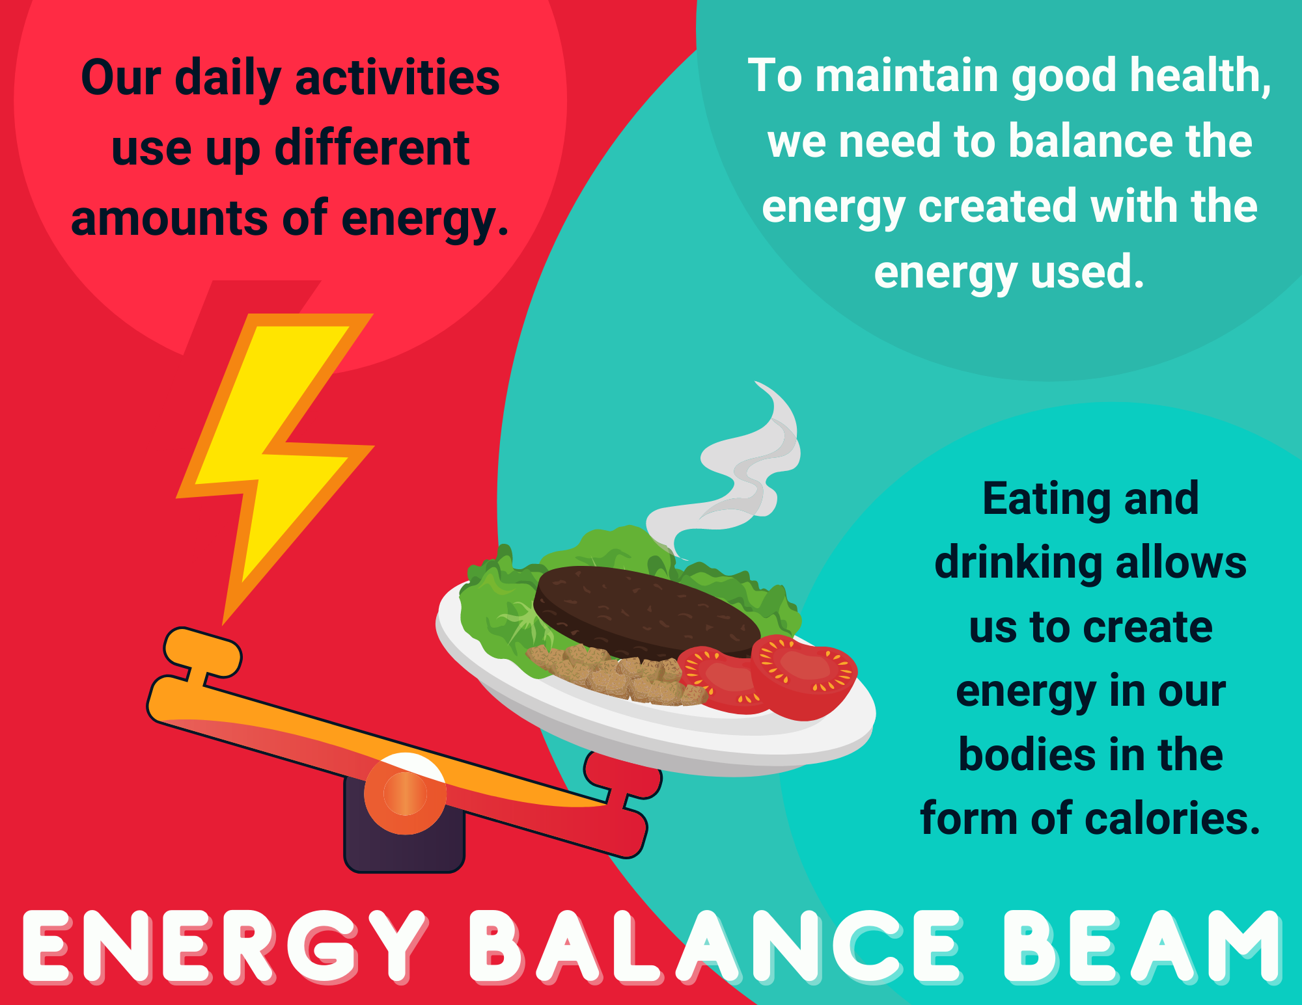

**Lesson Plan**

1. **Our body needs energy every second of every day to survive.**
   * The food we eat contains calories which our body uses for energy.
   * Every activity we do uses energy.
   * The chemical processes within our body make up our metabolism. Our metabolism uses energy every minute we are alive. This includes breathing, digesting, growing, sleeping, and keeping our heart and brain alive.
   * We use energy for thinking and moving. This includes sitting, studying, doing chores, playing sports, running, riding bikes, and all other activities.
     + The more active we are, the more energy we use.
     + The less active we are, the less energy we use.

**2. Matching the energy we take in, to the energy we use, is energy balance.**

* + It is important for our body to stay in energy balance.
  + When we are in energy balance, we are not gaining or losing weight
  + When we eat more energy than our body uses, we gain weight.
  + When we eat less energy than our body uses, we lose weight.

**3. People need different amounts of energy based on multiple factors.**

* + These factors include gender, age, height, weight, activity level, and presence of disease, among others.
  + The United States Department of Agriculture (USDA) has created charts that estimate how much energy your body needs. **(See Daily Energy Intake Chart handout)**

**4. What does the word diet mean to you?** (Possible answers include: to lose weight,

gain weight, or become healthier).

* + Many people think of diet as an eating plan to follow for a certain amount of time.
  + A diet is simply what we eat and drink every day.
  + Some people have healthy diets, while others follow unhealthy diets.

**5. Healthy diets are eating patterns that are balanced and include a variety of**

**foods from all the food groups in moderation.**

* + Healthy diets balance the energy you eat with the energy you use based on your age, health needs, and activity
  + We need a variety of foods from each of the food groups in order to get all of the nutrients our bodies need.
  + Moderation is eating your daily recommended amount of each food group.
  + In addition, a healthy diet incorporates regular physical activity.
  + **Optional Activity: Mark Your Moves**

**6. A fad diet is an unhealthy eating pattern that promises very fast results and**

**easy lifestyle changes.**

* + People try fad diets because of the promised results.
  + Many fad diets are unhealthy and only work for a short time, if they work at all.
  + Many fad diets are unhealthy because they can include restrictions that leave out entire food groups.

**7. Healthy weight loss.**

* + Our body needs food from all of the food groups to make sure we get all of the nutrients we need to stay healthy.
  + A healthy weight loss diet involves slowly losing weight by increasing exercise and healthy foods and decreasing inactivity and unhealthy food.
  + **See 10 Ways to Spot a Fad Diet handout.**
  + **Optional Activity: Spotting a Fad Diet.**

**8. Wrap Up**

* + Our body needs energy every second of every day to survive.
  + It is important for our body to stay in energy balance.
  + People need different amounts of energy based on multiple factors.
  + Diet is what we eat and drink every day.
  + Healthy diets are eating patterns that are balanced and include a variety of foods
  + A fad diet is an unhealthy eating pattern that promises very fast results and easy lifestyle changes.
  + Unhealthy eating patterns can lead to eating disorders.

**Handout:** 10 Ways to Spot a Fad Diet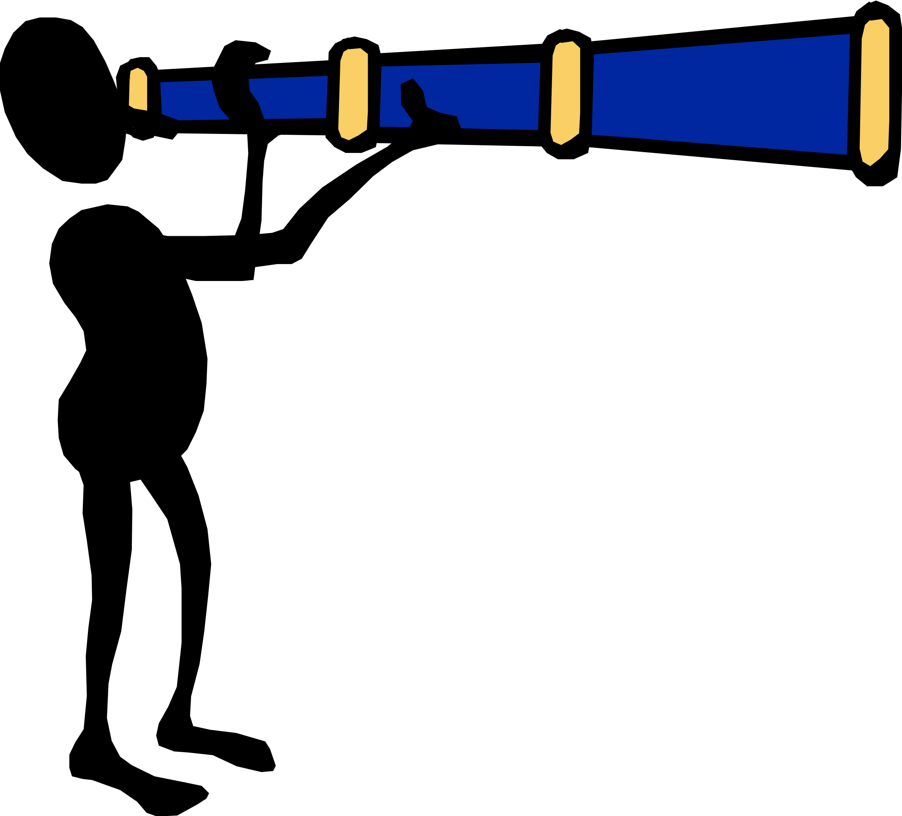

1. The diet recommends eating special foods that can help you burn fat.
2. The diet recommends eating only one certain food.
3. The diet recommends eating only foods from a certain food group.
4. The diet recommends eating only one specific nutrient or eating all but one nutrient.
5. The diet recommends combining certain foods to lose weight, even though there is no scientific research to support it.
6. The diet promises you will lose weight very fast, more than 2 pounds a week.
7. There is a product that needs to be purchased for the promised results.
8. The diet doesn’t include recommendations for increasing your physical activity.
9. Although the diet isn’t appropriate for people with certain diseases, there are no warnings provided.
10. The diet claims that losing weight will be effortless.

Adapted from the American Heart Association at http://www.americanheart.org/presenter.jhtml?identifier=509

**Activity:** Spotting a Fad Diet

**Spotting a Fad Diet**

**Instructions**

* **This activity goes with the Energy Balance Beam Lesson Plan.**
* Use the handout titled “10 Ways to Spot a Fad Diet” to identify which of the following diets are considered fad diets and why.

****

1. This diet promotes weight loss (up to 6-8 pounds a week) by severely restricting the amount of carbohydrates you can consume.

Is this a Fad Diet? _____Yes _____No

Why or why not?**_____________________________________________**

__________________________________________________________

__________________________________________________________

2. This diet promises weight loss by replacing all meals with a serving of grapefruit.

Is this a Fad Diet? _____Yes _____No

Why or why not?**_____________________________________________**

__________________________________________________________

__________________________________________________________

3. This diet promises weight loss by taking a supplement in the form of a pill.

Is this a Fad Diet? _____Yes _____No

Why or why not?**_____________________________________________**

___________________________________________________________

___________________________________________________________

1. This diet promises weight loss by eating a variety of foods from all of the food groups and increasing physical activity.

Is this a Fad Diet? _____Yes _____No

Why or why not?**_____________________________________________**

___________________________________________________________

___________________________________________________________

5. This diet promises weight loss by eating only high-protein foods.

Is this a Fad Diet? _____Yes _____No

Why or why not?**_____________________________________________**

___________________________________________________________

___________________________________________________________

Record any thoughts or comments you had on this activity below**:**

_________________________________________________________________

_________________________________________________________________

_________________________________________________________________

**Spotting a Fad Diet Answer Key**

**Instructions**

* **This activity goes with the Energy Balance Beam Lesson Plan.**
* Use the handout titled “10 Ways to Spot a Fad Diet” to identify which of the following diets are considered fad diets and why.

****

1. This diet promotes weight loss (up to 6-8 pounds a week) by severely restricting the amount of carbohydrates you can consume.

Is this a Fad Diet? __**X**___Yes _____No

Why or why not?**_**This is considered a fad diet because it promises weight loss of more than 2 pounds a week (#6).

1. This diet promises weight loss by replacing all meals with a serving of grapefruit.

Is this a Fad Diet? __**X**__Yes _____No

Why or why not? This is considered a fad diet because it recommends that you only eat one food (#2).

3. This diet promises weight loss by taking a supplement in the form of a pill.

Is this a Fad Diet? __**X**__Yes _____No

Why or why not? This is considered a fad diet because it is recommending you purchase a supplement for the weight loss (#7).

1. This diet promises weight loss by eating a variety of foods from all of the food groups and increasing physical activity.

Is this a Fad Diet? _____Yes __**X**___No

Why or why not? This is not considered a fad diet because it promotes healthy eating from all of the food groups along with getting enough physical activity.

5. This diet promises weight loss by eating only high-protein foods.

Is this a Fad Diet? __**X**__Yes ____No

Why or why not? This is considered a fad diet because it promotes weight loss by eating only one specific nutrient.

**Activity:** Mark Your Moves

(see next page)

