**Breakfast Around the World Activity**

* Students select a country.
* Students research the traditional breakfast of their chosen country.
* Students list the foods eaten at breakfast in their chosen country.
* Students create a timeline or chart to show the sources of breakfast.
  + For example: If tofu is chosen, create a timeline of where it comes from...growing the soybean, processing it, packaging it, sending it to the store, even how one would prepare it in the kitchen.
* Students present what they learned.

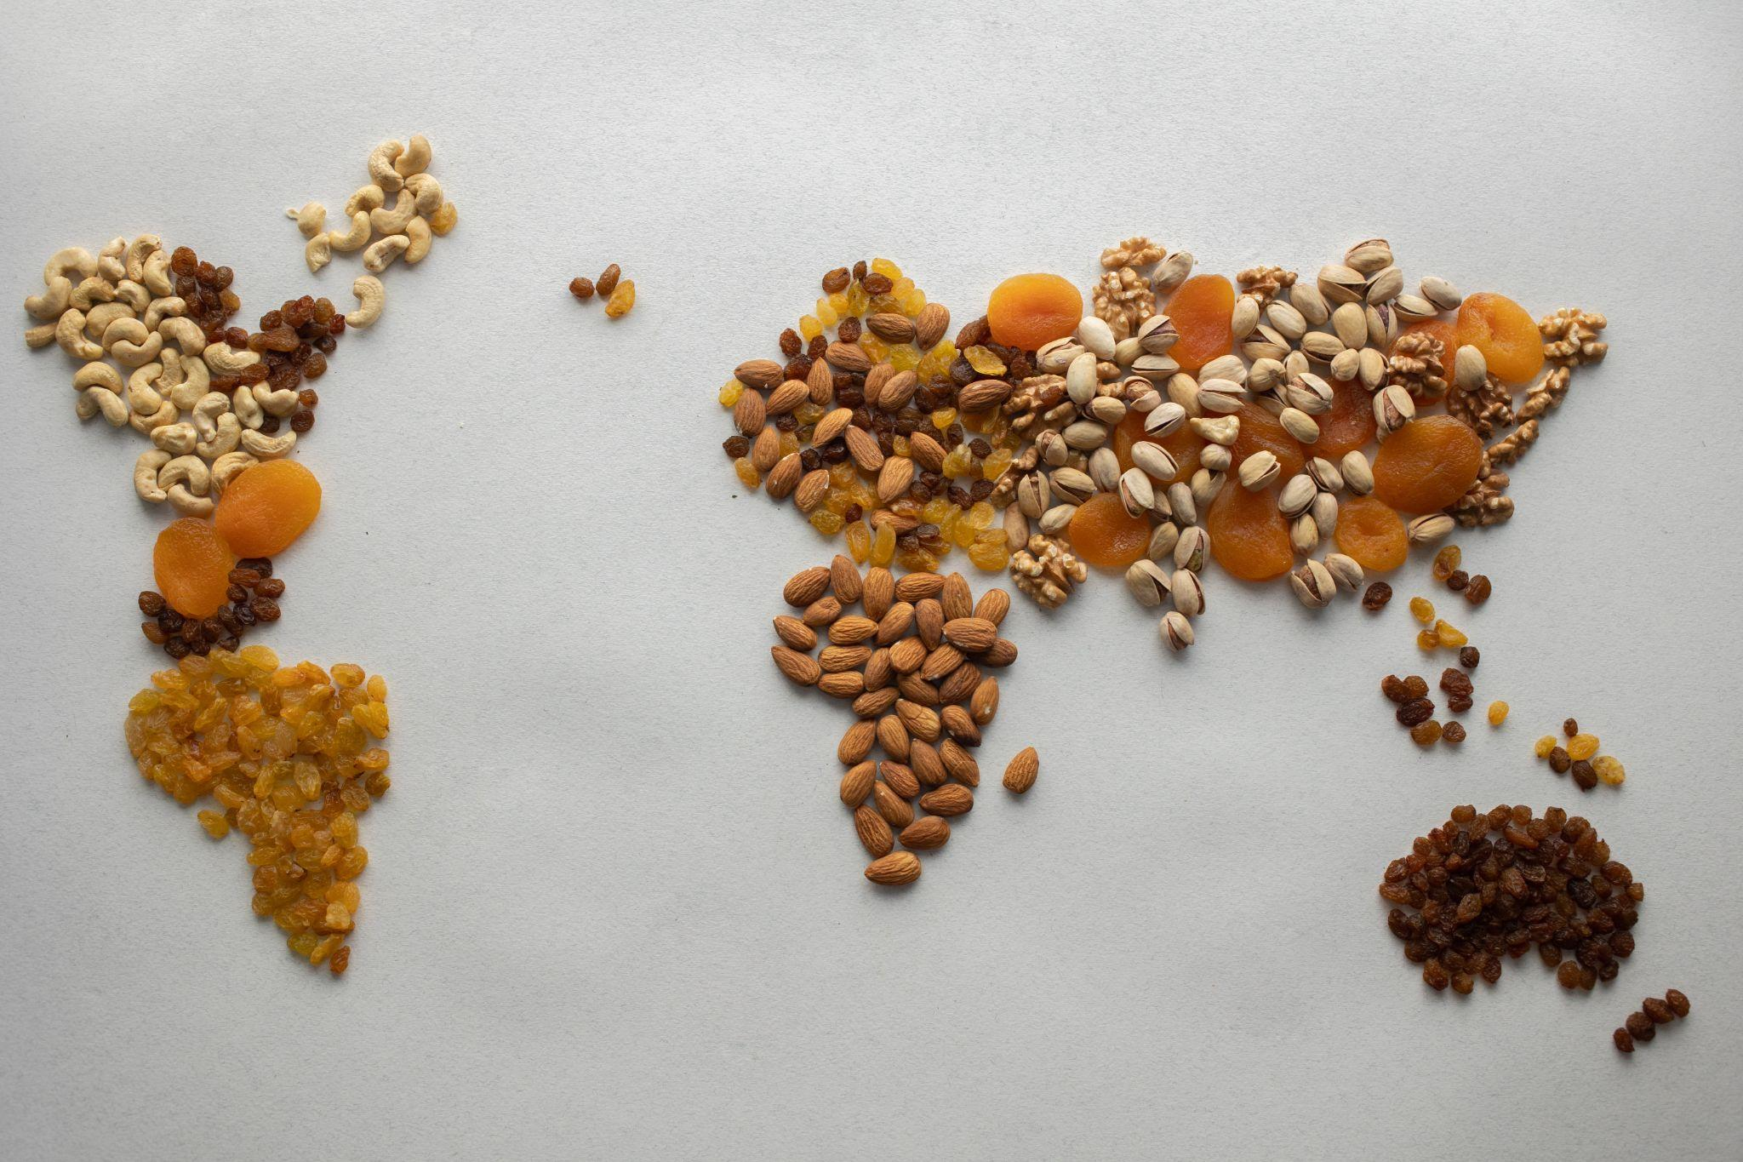

Photo by Monstera

What’s for Breakfast?